**Communication title [Book Antiqua, 12 pt, centred]**

Name1 Surname1,a Name2 Surname2,a …, Name3 surname3b [complete list of authors, Book Antiqua, 9 pt., centred, single interlined, presenting author underlined]

*aDepartment, University of the authors 1 and 2, Mailing Address*

*bDepartment, University of the author 3, Mailing Address*

e-mail: presenting.author@xxx.xx (E-mail address of the presenting author)

Abstract of your communication; Book Antiqua 9 pt., justified and single interlined. Maximum length: 1 sheet 170 mm × 240 mm. Figures, graphics, schemes or tables will be inserted in the text (centred or at the margins at your election). It is not allowed to remove the blank lines between title, authors, address and text. **The use of colour figures is encouraged.** Please let one empty line before and after the figure. If you want to insert a caption, use Book Antiqua 9 pt, centred and single interlined.

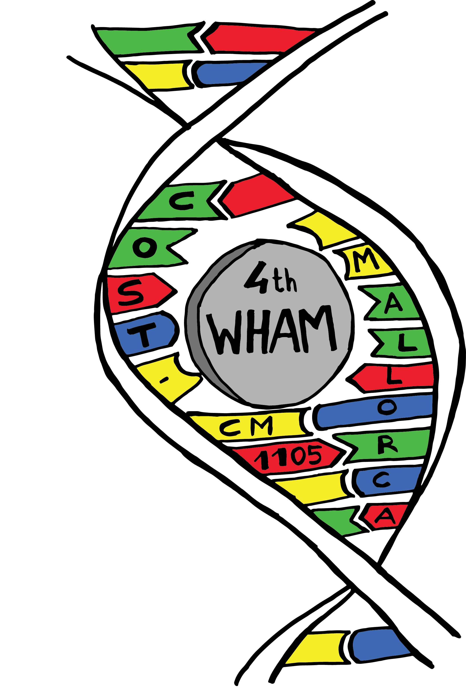

The references should be inserted in the ACS format,[1] and they will be written down at the end of the text; Book Antiqua 9 pt., justified. It is preferred to include only one reference per number.[1-3]

***Acknowledgments***

Here you can acknowledge financial support; Book Antiqua 9pt, justified.

***References***

[1] N. Surname, N. Surname, *Journal* **Year**, *Volume*, Pages.

[2] N. Surname, N. Surname, *Book*. Publishing Company, City, Year.

[3] N. Surname, N. Surname, *Chapter* in *Complete Title* (Editor). Publishing Company, City, Year, Pages.